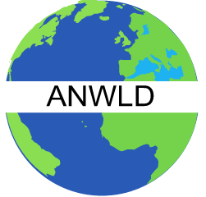
ASSOCIATION OF NIGERIAN WOMEN
LEADERS IN DIASPORA, WASH. D.C.



“DIASPORA NATIONAL DAY OF PRAYER FOR NIGERIA”

VENUE: Nigerian Chancery, 3519 International Court, N.W. Washington D.C. 20008

WHEN: Saturday, February 4th2012
Time: 11: 00 – 2: 00 p.m. Prompt

WHO: ALL CHRISTIANS & MUSLIMS

AGENDA : TO STOP THE KILLINGS OF INNOCENT MEN, WOMEN, & CHILDREN FOR A BETTER TOMORROW – “PEACE & UNITY”

RSVP: National President, Mrs. Rita Amachree – 202-320-8402; and Public Relations officer, Mrs. Joyce James Jack – 301-221 - 5230

